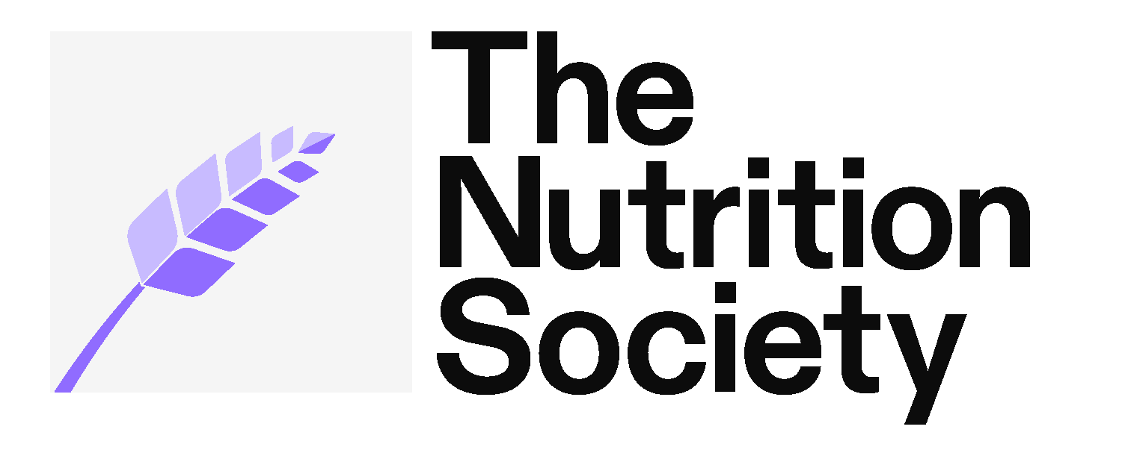
The Nutrition Society
Boyd Orr House
10 Cambridge Court
210 Shepherds Bush Road
London W6 7NJ

NUTRITION SOCIETY GRANTS CLAIM FORM
CLAIMANT NAME
MEETING / ACTIVITY
VENUE /LOCATION
DATE OF MEETING /
ACTIVITY
DETAILS OF CLAIM | Claims are paid directly into individual bank accounts by electronic transfer.
Train/Airfare:
Taxi:
Accommodation:
Other Expenses (please specify):

FOR NOTE
- In order to claim your grant, you will need to provide all VAT proofs of purchase for your registration, travel and /or accommodation. These will then need to be sent with your claim form. Credit/debit card receipts are not acceptable.
- Your grant can be claimed immediately after your event, please ensure all the scanned/photograph copies of your VAT receipts have your name clearly shown.
- Please claim within three months of the event.
- When you have completed this claims form please send it with clear images of your receipts to membership@nutritionsociety.org with Conference Grant Claim 2023/4 in the subject line
- You should also include short report on the conference and what you feel you gained from it and how the conference grant from the Society helped. If you have any photos of you presenting at the event, please feel free to include these too. We may choose to include you in promotion of the grants programme.

It is our intention to settle accounts by BACS transfer within 30 working days of receipt and we would be grateful if the following details could be provided to enable this. They will be kept on our system unless we are informed otherwise.
**If your bank account is overseas, please include the Swift Code, IBAN and or EBAN codes **

Name on bank account:
Bank name:
Bank address:
Account name:
Account number:
Sort Code:
Swift Code
IBAN:
EBAN / BIC:
Cost of claim
Contact phone number:
I confirm that these expenses have been incurred during activities engaged in for the aforementioned person and conference and are not being met by any other party.

SIGNED: DATE:

Return form to:
Email: membership@nutritionsociety.org
The Nutrition Society, Boyd Orr House, 10 Cambridge Court,
210 Shepherd’s Bush Road, London W6 7NJ, UK
Telephone: 020 7602 0228

